

CLOUD COMPUTING LAB
BSE ( V-B )

Submitted By:
Musfira Farooq
Roll No:
2023-BSE-045
Submitted To:
Sir Muhammad Shoaib

LAB 13

Terraform IAM Management with AWS

Task 0 — Lab Setup (Codespace & GH CLI)
Objective: Set up GitHub Codespace and connect.
- Create Codespace & list
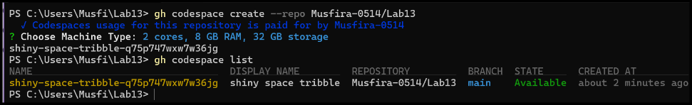
- SSH into Codespace
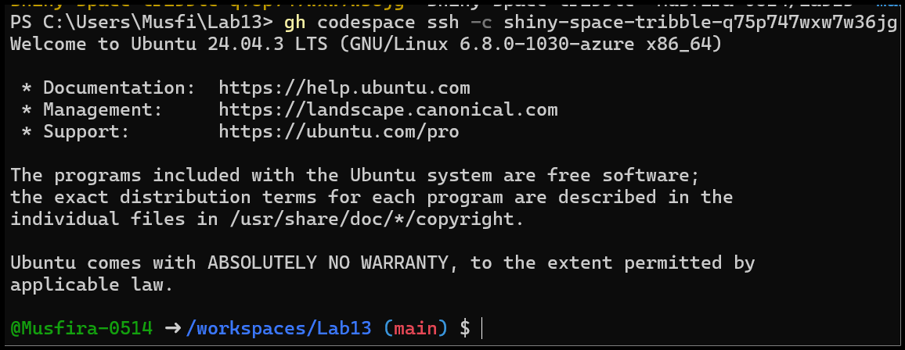
Task 1 — Create IAM Group and Output Details
Objective: Create IAM group developers and output details.
- Project directory creation
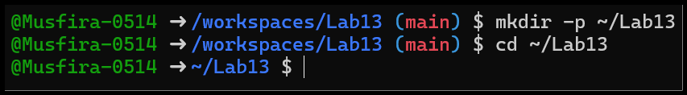
- Create main.tf file
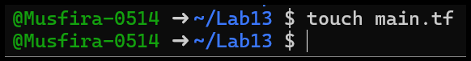
- main.tf content
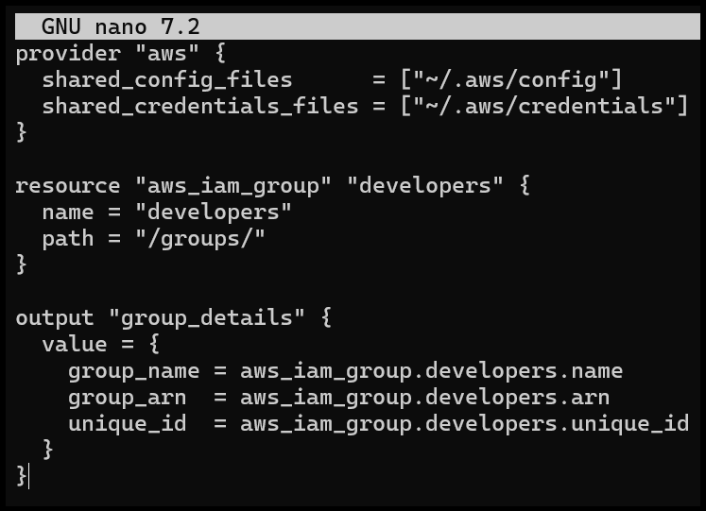
- Terraform init
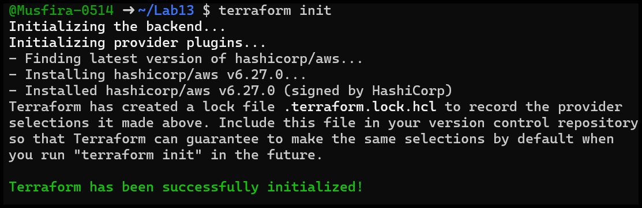
- Terraform apply
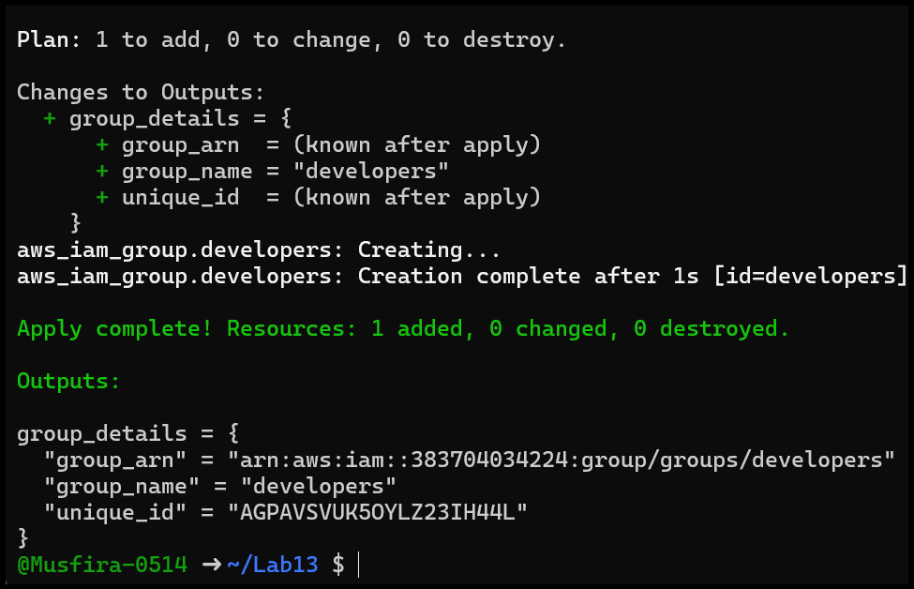
- Terraform output
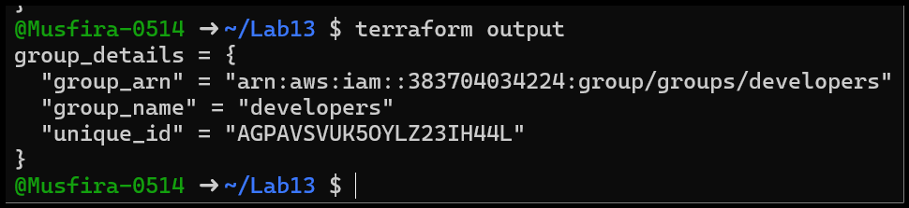
- AWS Console verification
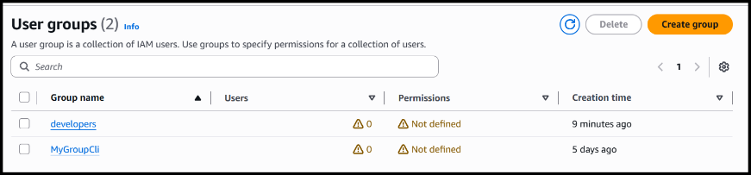
Task 2 — Create IAM User with Group Membership
Objective: Create IAM user loadbalancer and add to developers group.
- Updated main.tf with user
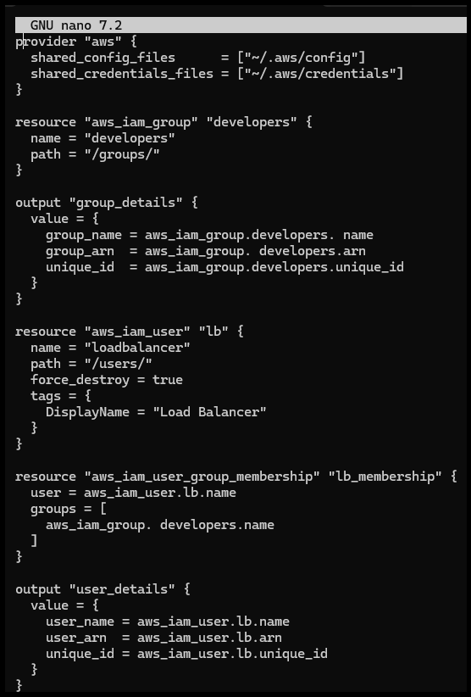
- Terraform apply
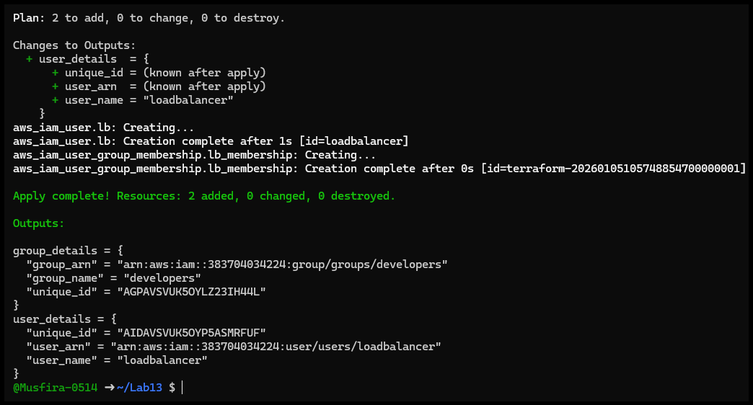
- Terraform output
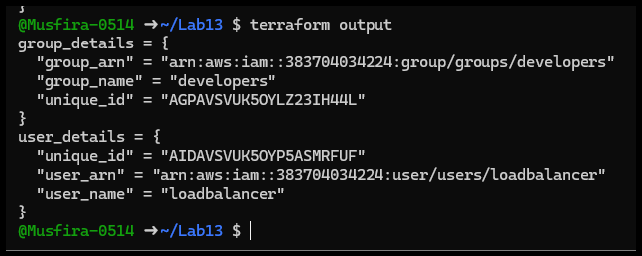
- AWS Console user verification
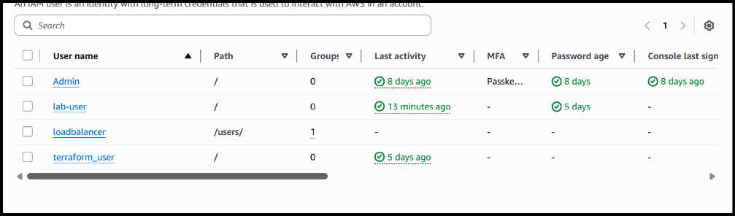
- User group membership verification
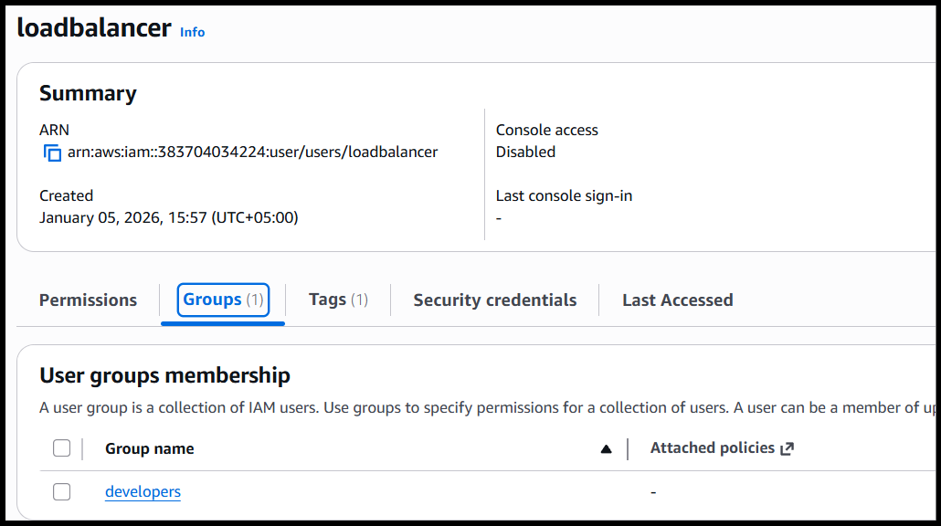
Task 3 — Attach Policies to IAM Group
Objective: Attach AmazonEC2FullAccess & IAMUserChangePassword policies.
- Updated main.tf with policy attachments
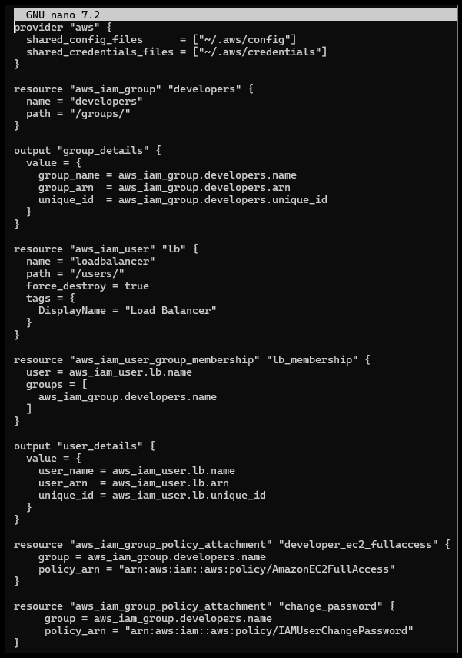
- Terraform apply
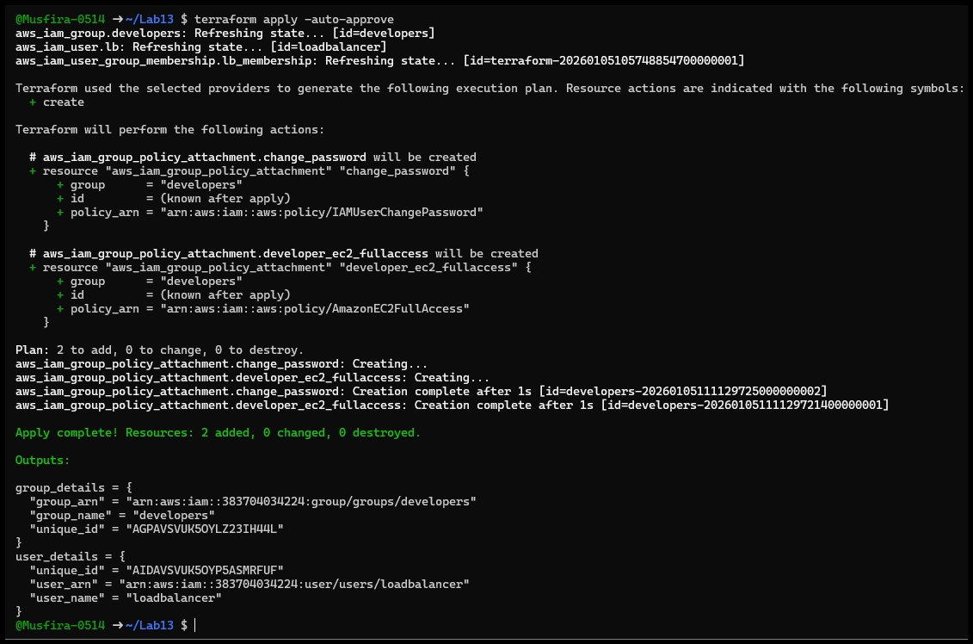
- AWS Console verification
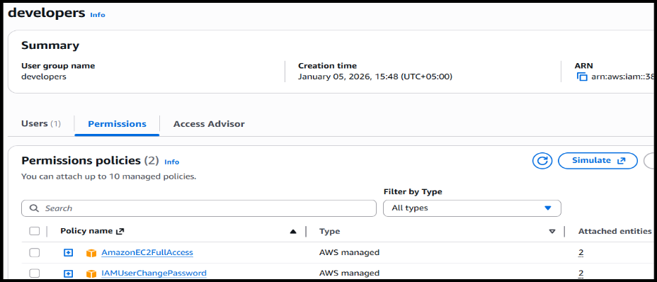
Task 4 — Create Login Profile for IAM User
Objective: Create login profile using bash script and null_resource.
- variables.tf
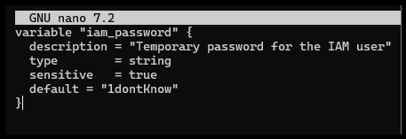
- Bash script content
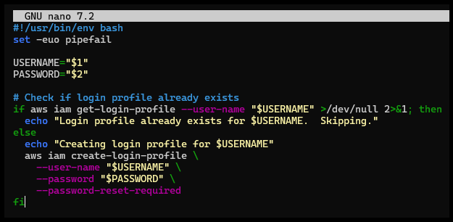
- main.tf null_resource
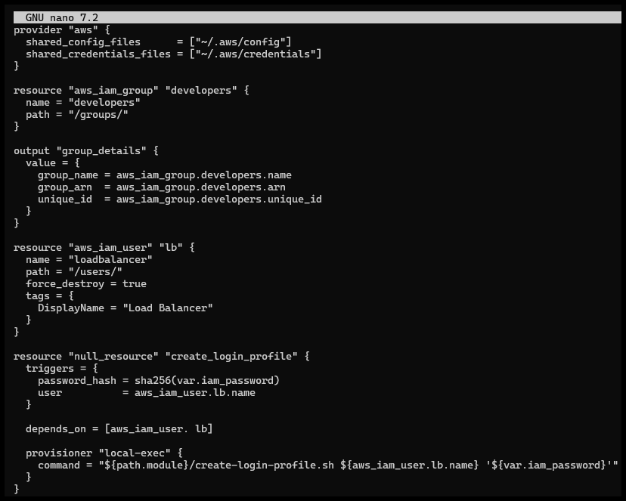
- Terraform apply
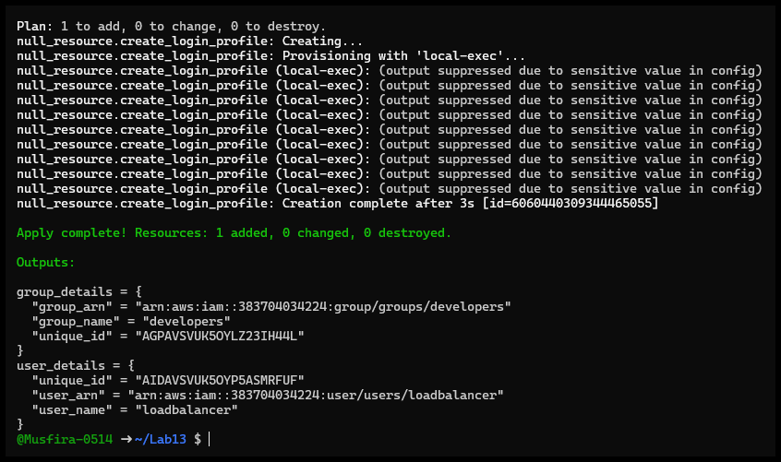
- AWS CLI verify login profile
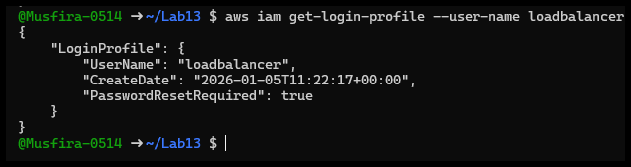
- AWS Console login
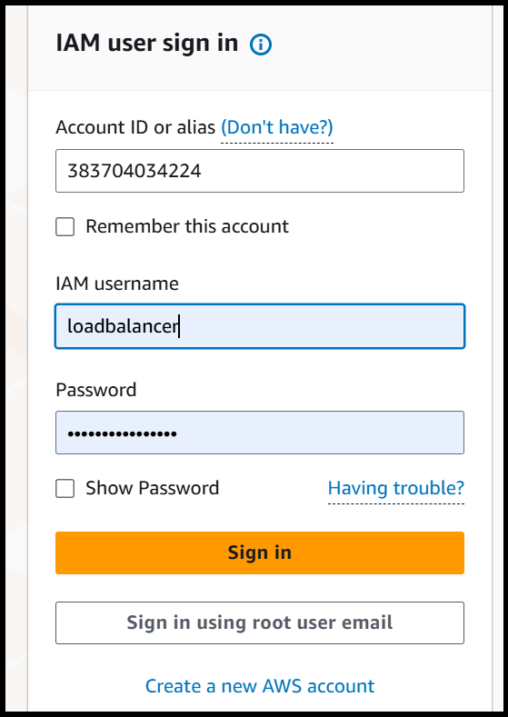
- Password reset prompt
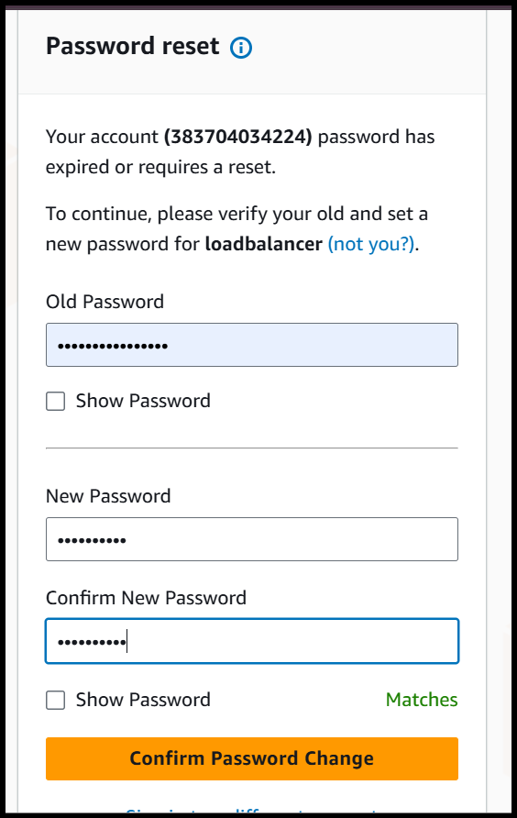
Task 5 — Generate Access Keys for IAM User
Objective: Generate IAM access keys.
- main.tf access key resource
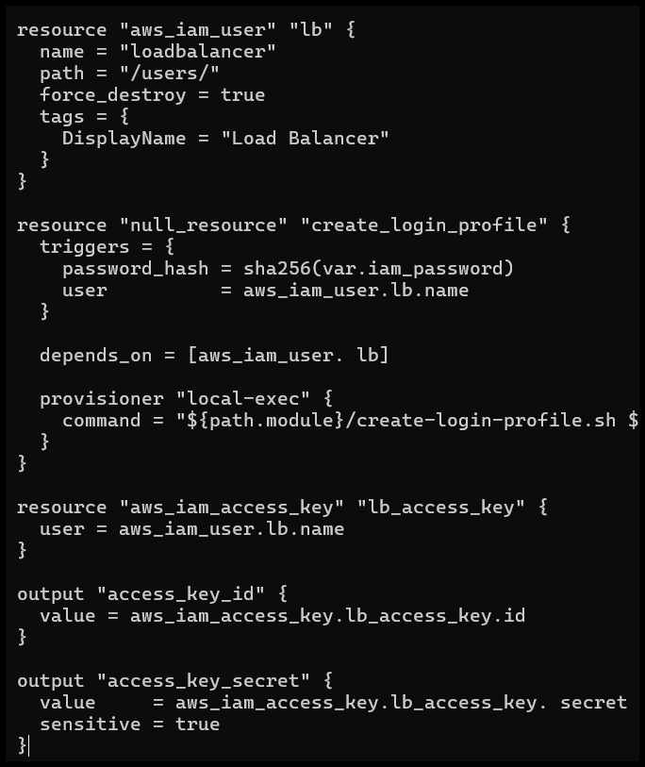
- Terraform apply
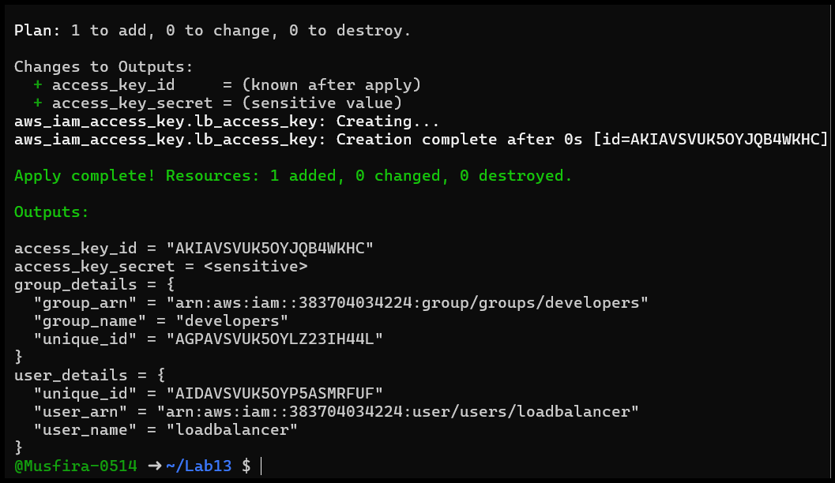
- Terraform output
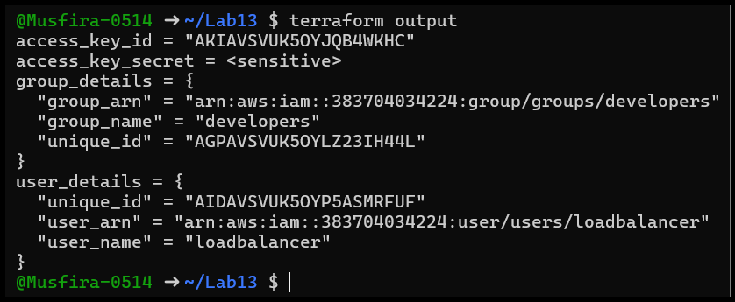
- tfstate secret
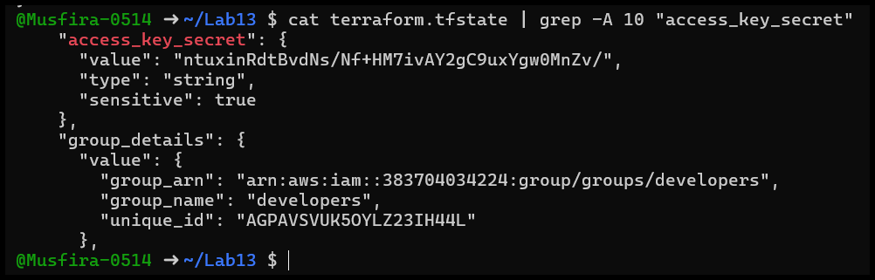
- AWS Console verification
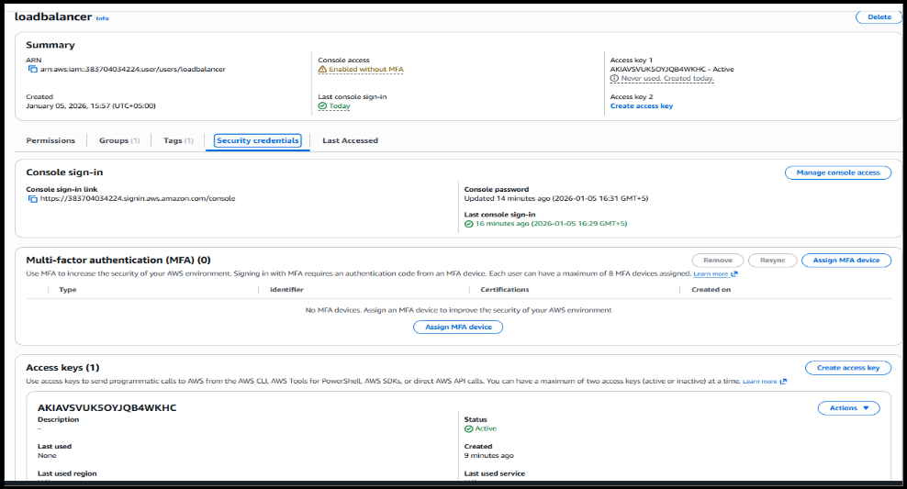
Task 6 — Implement Terraform Remote State with S3
Objective: Use S3 backend for remote state.
- S3 bucket create
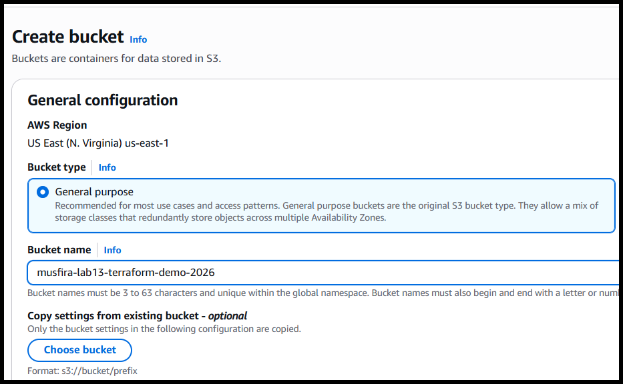
- Enable versioning
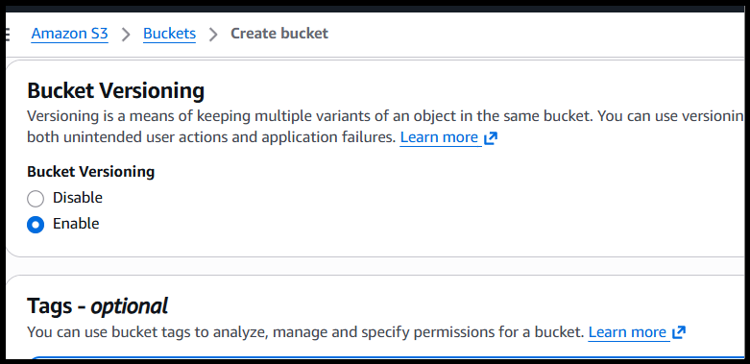
- main.tf backend configuration
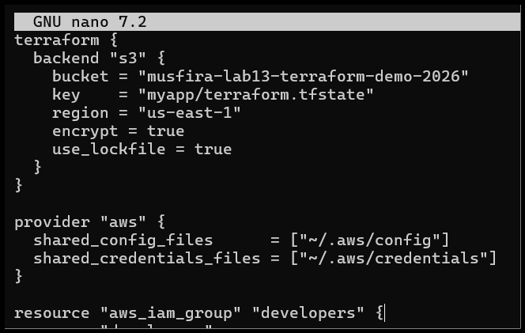
- Terraform init & migrate
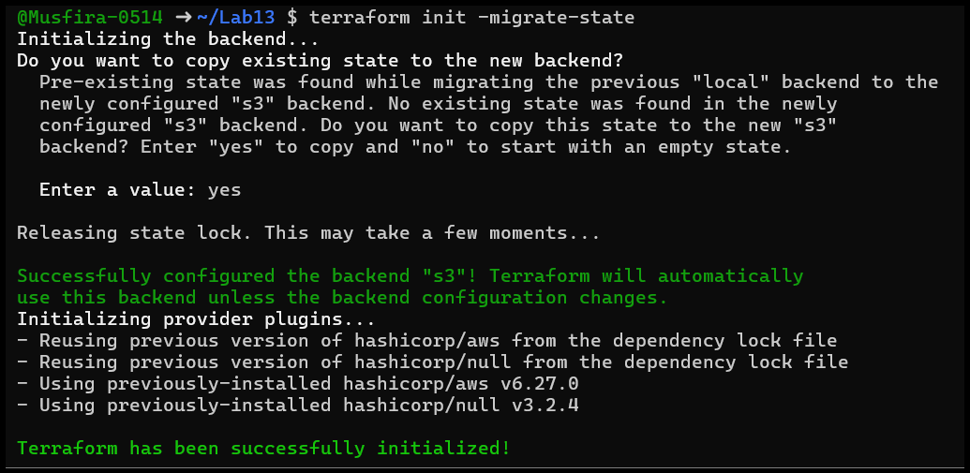
- Terraform apply
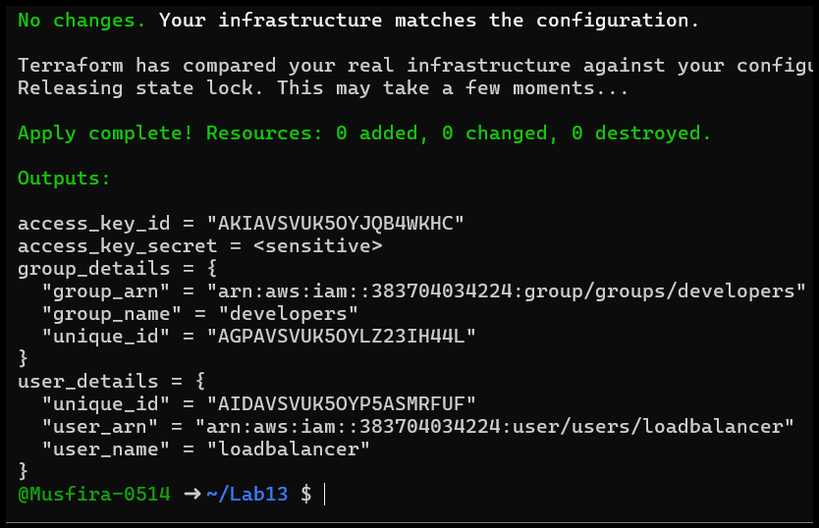
- S3 terraform.tfstate file
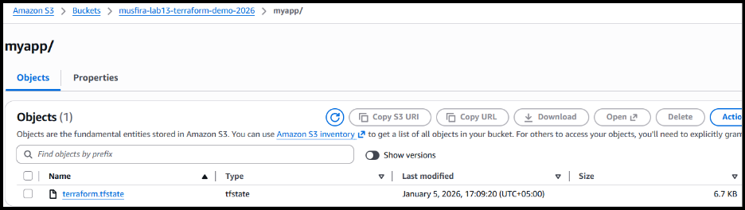
- Local state backup
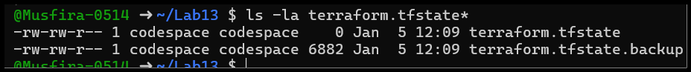
- Terraform destroy
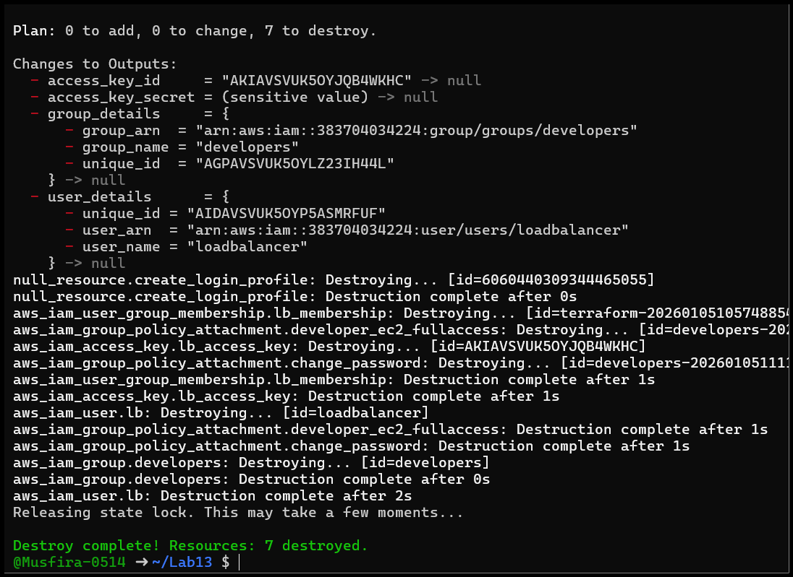
- S3 state after destroy
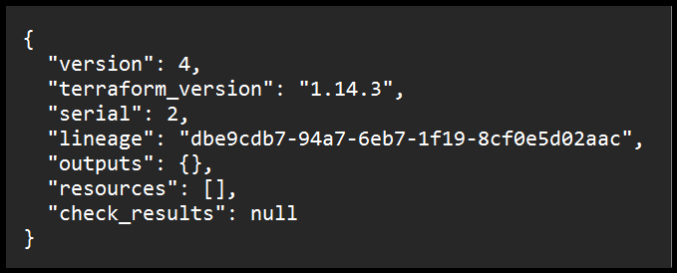
Task 7 — Create Multiple Users from CSV File
Objective: Dynamically create multiple IAM users from CSV.
- locals.tf
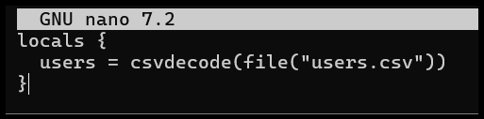
- users.csv
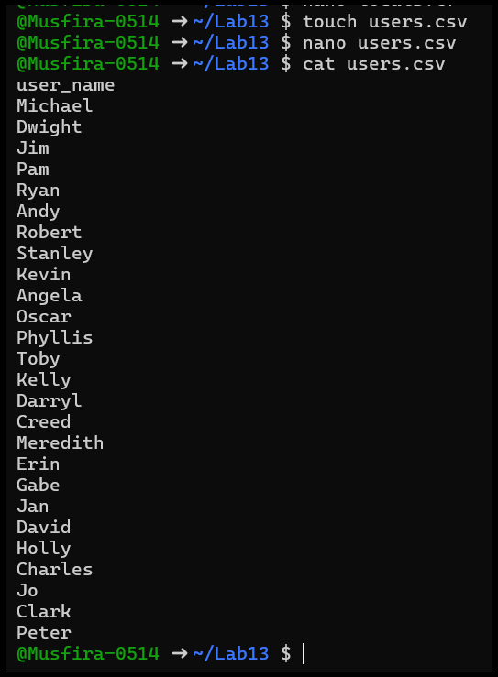
- main.tf multiple users
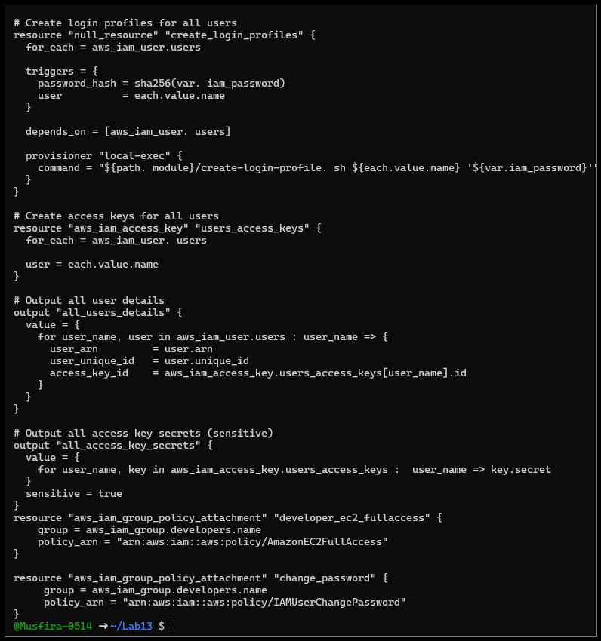
- Terraform init
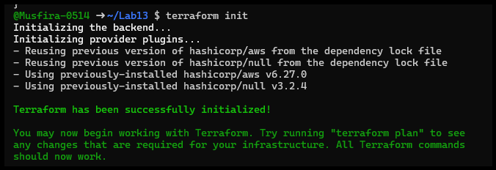
- Terraform apply
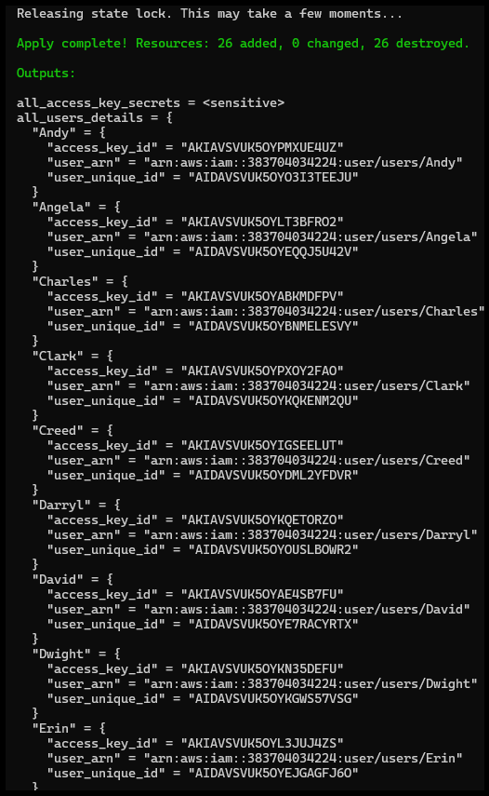
- Terraform output
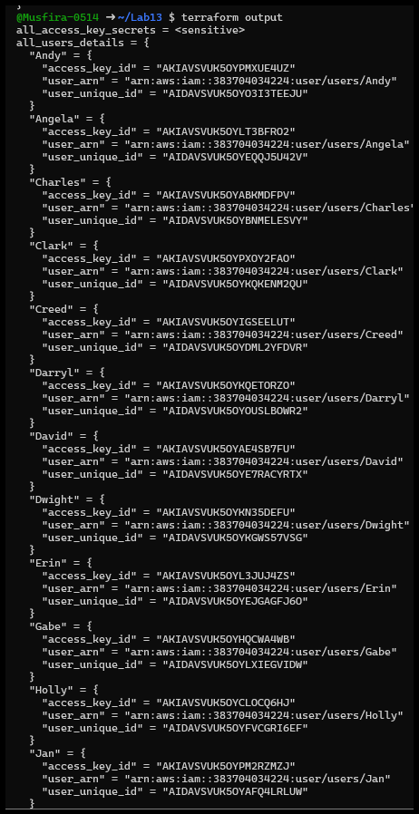
- tfstate secrets
- AWS Console all users
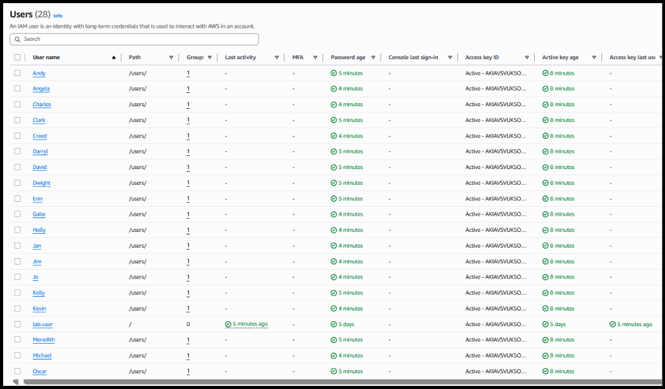
- AWS Console group members
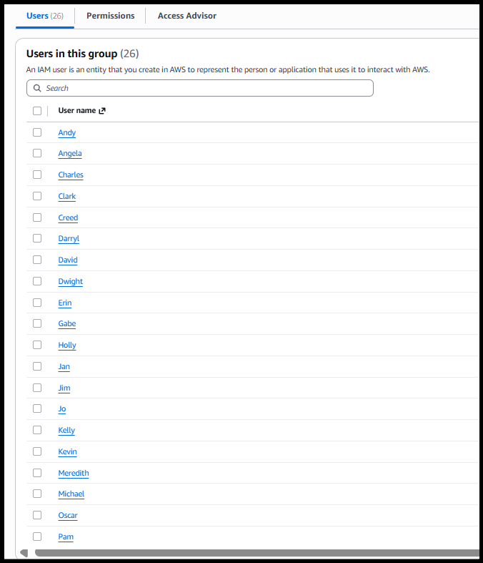
- AWS Console user access key
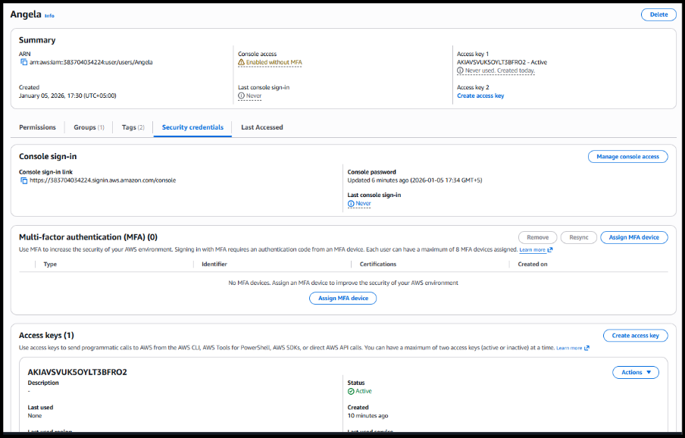
- S3 state for multiple users
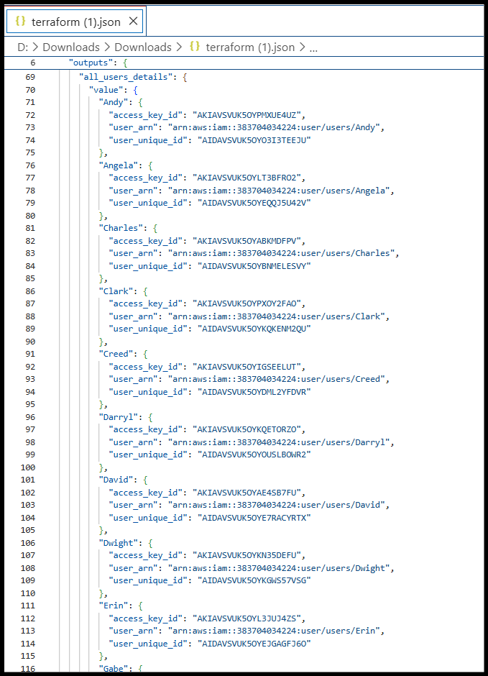
Cleanup — Destroy Resources & Verify
- Terraform destroy complete
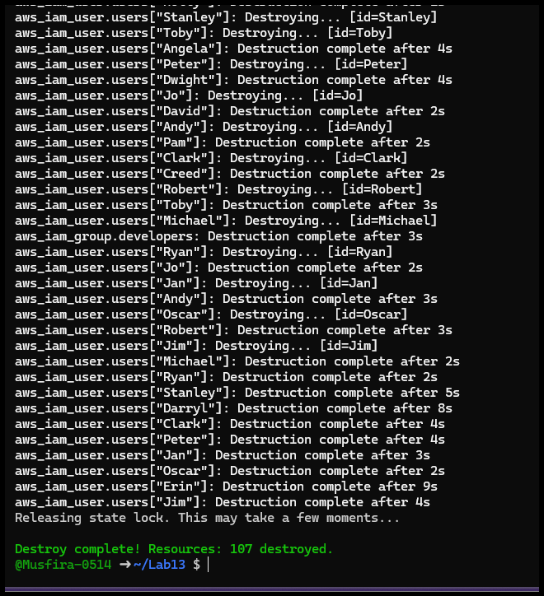
- AWS Console users deleted
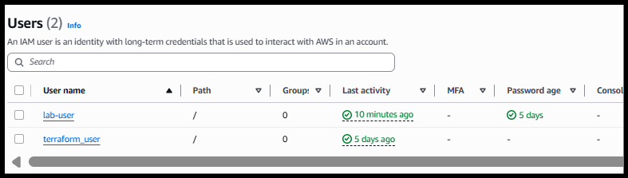
- AWS Console group deleted
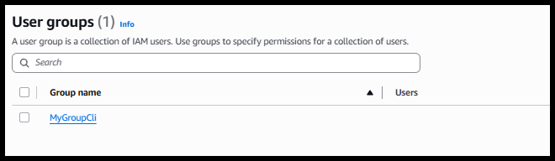
- S3 empty state
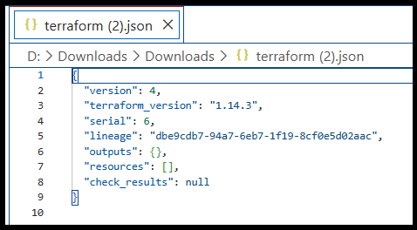
- Final project files
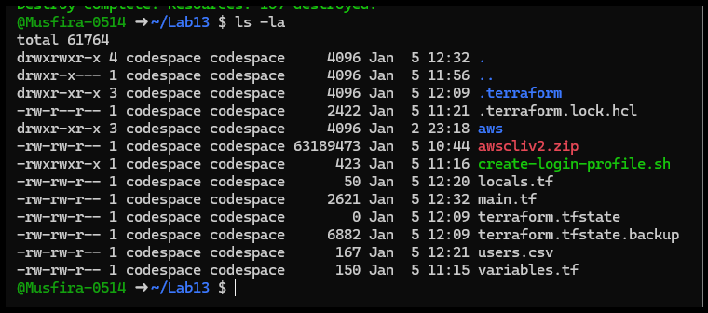
- S3 bucket deleted (optional)
